**9. Using EventBridge for Extending the Architecture**

**Architecture**

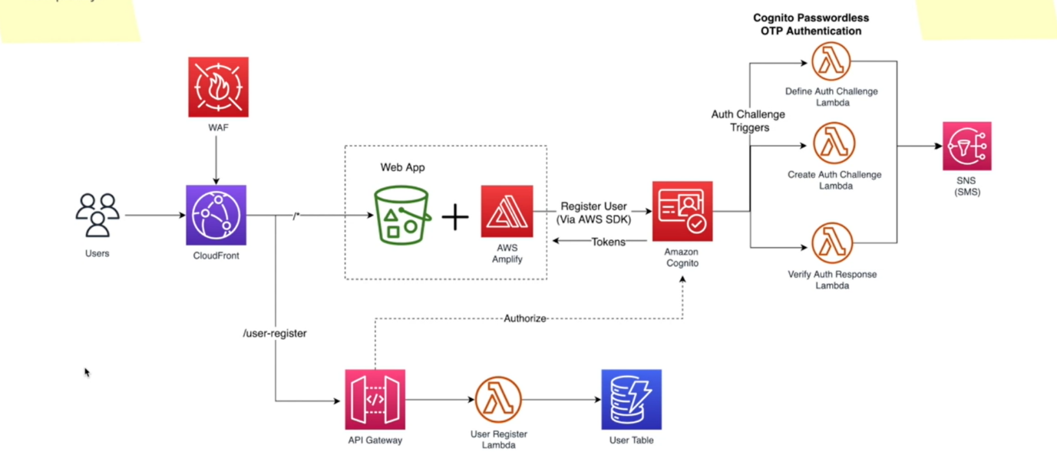

* why I suggest this type of an architecture for application and what we are trying to achieve from this. So first and foremost, why did we use an event bridge here? Nowadays, in most of the serverless architectures, we tend to use event bridge. One of the reasons is that Event Bridge make it very easy to extend the functionalities of your application.
* For example, I heard that they are introducing another feature to register these corporate vehicles because one company can have multiple vehicles and they are planning to add that functionality to the application.
* So, in that case, we can ingest those events also into event bridge and in the event body itself, there will be some identifier, maybe, let's say the type corporate, then we can easily write another event rule, and that event rule will only filter those corporate events and then we can send it to whatever the target we want.
* Now let us imagine the corporate events are being differently processed and there will be a different
* external system. So, in that case we can filter those events and then route them to that external system. So, it is very easy to extend our application, giving more focus on extending the current application architecture.